**Test Automation - Assessment**

**Application to be tested - URL:**

<https://www.amazon.in>

**Instructions:**

* Use different locators
* Include Assert statements
* If any of the steps is missing for the test scenario, you can pick alternate step/scenario from the same website and proceed with the automation
* Use Chrome Browser
* Include Time delays ( sleep/implicit/explicit) wherever needed

**Tasks:**

* Go to https://www.amazon.in

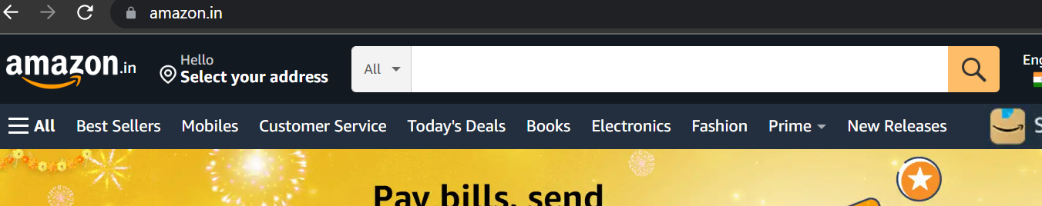

* Click the “Today’s Deals” tab

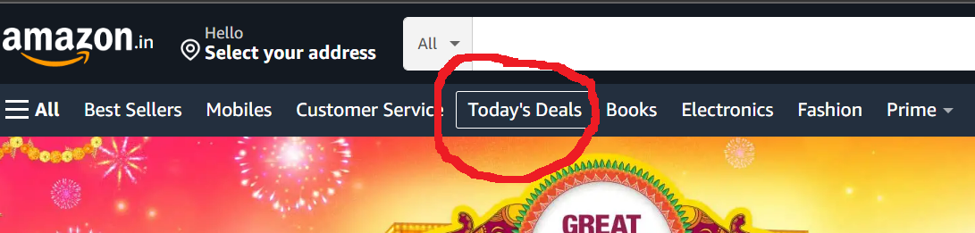

* Click the “Clearance” link

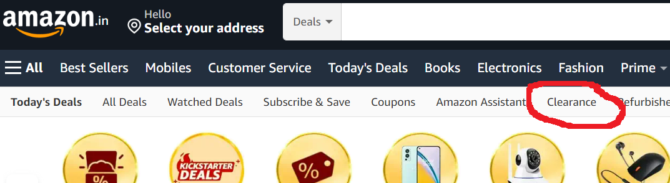

* Click “Watches”

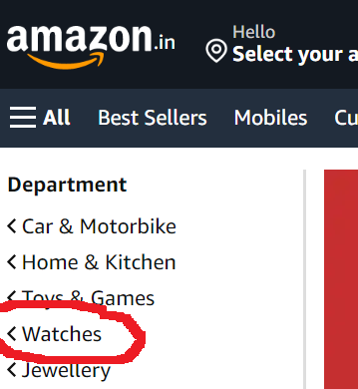

* Click “Get it Today” checkbox

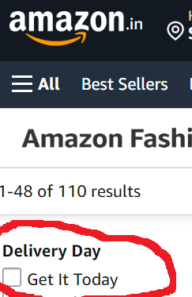

* Validate if “RESULTS” message is displayed
* Validate if the first item has item name containing “Watch”

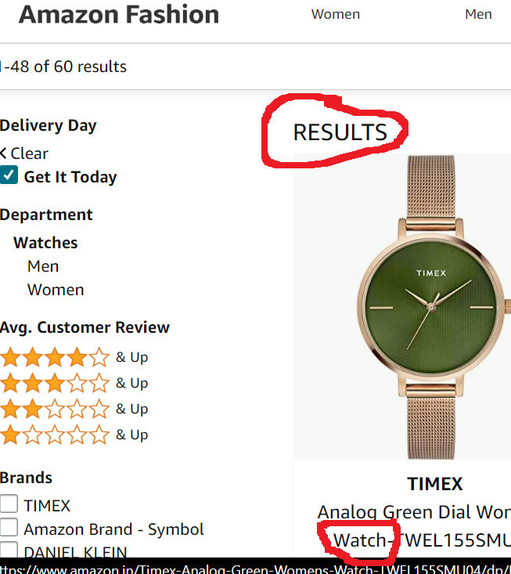

**Refer screenshot for each step**